Ideation Phase
Define the Problem Statement

Date | 02 November 2025
Team ID | NM2025TMID00562
Project Name | Laptop Request Catalog Item
Maximum Marks | 4 Marks

Empathy Map Canvas:

In the Empathize & Discover phase, the team observed how employees, managers, and IT staff handle the process of requesting laptops in the organization. They found that most employees feel frustrated and helpless when their requests get delayed or lost due to manual approval and tracking methods.
By interviewing different stakeholders, the team learned that employees often rely on emails or verbal communication to request laptops, which causes confusion and inconsistent record-keeping. Managers struggle to manage multiple approval requests, while IT support faces challenges fulfilling requests with incomplete or unclear information.
Gathering these insights helped the team understand the real-world pain points of all users involved in the process. Employees want faster approvals and visibility, managers need clarity and control, and IT teams require complete information to fulfill requests efficiently.
Understanding these challenges revealed that an automated system with structured approval workflows, form-based submissions, and real-time updates would reduce stress and eliminate unnecessary delays.
These discoveries guided the team to design a ServiceNow-based Laptop Request Catalog Item that is simple, transparent, and efficient for everyone.

Example:

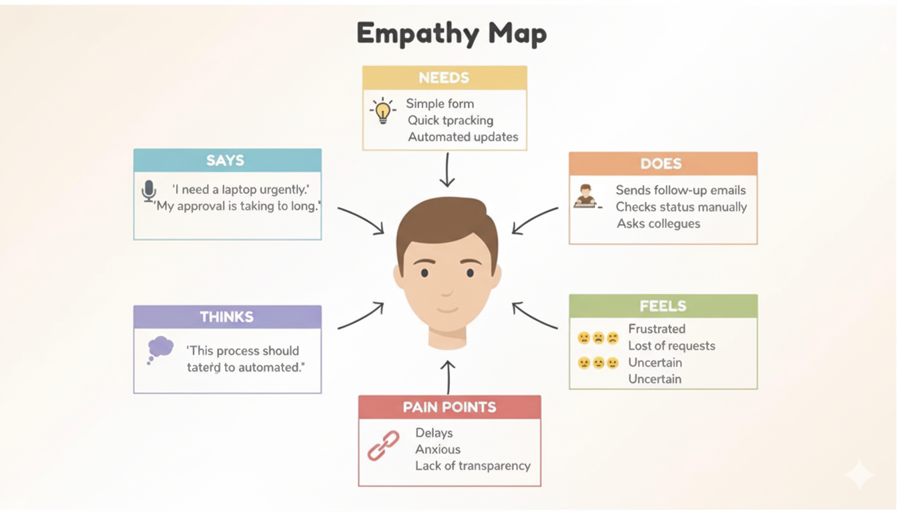

The empathy map helped the team visualize the challenges faced by employees and managers during laptop requests. It highlights their pain points, emotions, and actions that occur during the process.
It guided the creation of a centralized ServiceNow Catalog Item that provides:
- Clear visibility of request status,
- Auto-approval routing to the right manager,
- Notifications for updates, and
- Accurate, trackable fulfillment tasks for IT staff.
By deeply understanding users through empathy mapping, the team identified critical frustrations like approval delays, missing communication, and lack of request transparency. These insights helped design a smarter and more reliable Laptop Request Catalog Item that streamlines the process, saves time, and boosts user satisfaction.

